**2.3 I can select and use appropriate editing and formatting techniques to aid both clarity and navigation.**

All the text on my website is in a popular clear format from Google called *Sora*. I chose this because in my opinion it looks good, and was at the top of a few lists of the best online fonts to use. I also used it because many devices will have it, but have also put Sans-Serif for it to use alternatively.

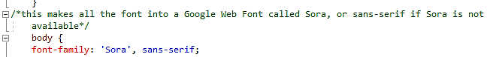

My website has clear buttons to navigate around it from any page to any other.

My website also shows which page you are on by keeping highlighted that tab/button:

